Conversion
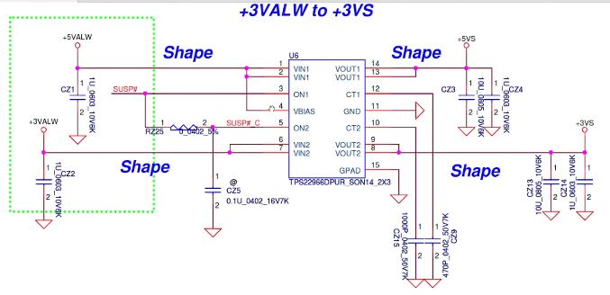
Always rails ko Switched rails me convert(conversion)
(Series Linear Regulator Type)
IC: TPS22966 / TPS2296 type
Kaam: Power ko ON / OFF shape karna (Enable control)

Real World Example
Laptop Sleep mode me hota hai:
+3VALW & +5VALW hamesha present rehte hain,
lekin CPU, USB, display ko power tab milti hai
jab EC SUSP# high karta hai.

🔹 Final Answer
👉 Is circuit me regulation nahi ho rahi,
ye sirf Always Power rails ko Switched Power rails me change kar raha hai –
same voltage, bas ON / OFF control.

“Always Rails → Switched Rails” ka matlab kya hota hai?

Laptop me power hamesha full ON nahi hoti
Laptop band hota hai tab bhi kuch circuits ko power chahiye hoti hai
jaise EC, charger IC, power button logic.
Isliye board me 2 type ki supply hoti hai:
Type | Kab ON hoti
Always Rails | Adapter lagte hi hamesha ON
Switched Rails | Power button dabane ke baad ON

Short Definition
Always Rails = +3VALW, +5VALW → standby power
Switched Rails = +3VS, +5VS → working mode power

